SOLUTION Olympic Advert

Use any appropriate software and address all the questions and requirements, complete as many sections as possible.

Part 1 Olympic Advert (50 marks)

In the lead up to the Olympics a local newspaper is running a competition offering its readers the chance to compete in a race at the official Olympic venue against some great Aussie legends.

Your task is to create a newspaper advertisement sample shown. Make sure that you adhere to the following guidelines:

- The advertisement is 20cm wide and 10cm high.
- The title ‘run against Aussie legends’ is white on black.
- The graphic (bottom left corner) should be any appropriate graphic/clipart.
- The text below the title should wrap around the graphic.
- The question should be in bold.
- The fill-in coupon should have a border as shown.
- The newspapers address should be in bold.
- The layout of the advertisement should be as in the sample.
- Add your name in the bottom right hand corner of the advertisement.
- Spell check your document.
- Save your work as name olympic, replacing name with your name and use the appropriate extension for the software used.
Save as: name Olympic to a folder titled with your name 40 marks

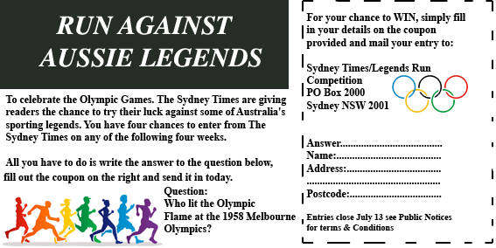
For your chance to WIN, simply fill in your details on the coupon provided and mail your entry to:
Answer the Question

Sydney Times/Legends Run
Competition
PO Box 2000
Sydney NSW 2001

Answer:
Name:
Address:
Postcode

Entries close July 13 see Public Notices for terms & Conditions

Text:

To celebrate the Olympic Games. The Sydney Times are giving readers the chance to try their luck against some of Australia's sporting legends. You have four chances to enter from The Sydney Times on any of the following four weeks.

All you have to do is write the answer to the question below, fill out the coupon on the right and send it in today. Question: Who lit the Olympic Flame at the 1958 Melbourne Olympics?

5 Marks
Ron Clarke lights the Olympic Flame. Melbourne 1956.

Evaluation
Create a word document called
xxxevaluation.doc (xxx = your initials) 10 Marks

For each graphic explain how you created the graphic and describe any methods that you used, explain why you chose the software for each graphic and evaluate your own work

Evaluation

Software Photoshop CS3 Extended | Gives more flexibility to create images
CS3 - Black box drawn with rectangular marquee tool, use - fill colour - black | Scaled to fit
CS3 - Coloured runners | From internet scaled and pasted in place
CS3 Olympic Rings | Copied and created with a transparent background, scaled and placed over advert
Box outline use erase for dashes

